Ecommerce Website Database– Database Testing Project
Introduction | About Project | Page 01
Step 01 | Database creation | Starting Page 01
Step 02 | Table creation | Starting Page 01
Step 03 | Data Insertion into Table | Starting Page 17
Step 04 | ER Diagram | Page 24
Step 05 | Database Verification and Testing | Starting Page 25
Introduction:
This project focuses on Database Testing for an E-commerce Website Database. The purpose of the project is to verify the accuracy, integrity, reliability, and consistency of data stored in the website's MySQL database.
The database represents the backend of a real-world e-commerce website, including major modules such as users, addresses, categories, products, product_images, inventory, carts, product_images ,orders, order_coupons, order items, payments, shipments, coupons, reviews, wishlists, wishlist_items and notifications.
The project also covers CRUD testing, Primary Key and Foreign Key validation, duplicate data testing, JOIN testing, aggregate function testing, order total validation, payment validation, data consistency testing, boundary-value testing, GROUP BY/HAVING testing, and real-world e-commerce business-rule testing.
Step 01:
Database Creation:
CREATE DATABASE ecommerce_testing ;
USE ecommerce_testing;
Step 02:
Table Creation:
-- ============================================================
-- 1. USERS
-- ============================================================
CREATE TABLE users (
user_id INT AUTO_INCREMENT PRIMARY KEY,
first_name VARCHAR(50) NOT NULL,
last_name VARCHAR(50) NOT NULL,
email VARCHAR(150) NOT NULL UNIQUE,
password_hash VARCHAR(255) NOT NULL,
phone VARCHAR(20) UNIQUE,
user_type ENUM('Customer', 'Admin') NOT NULL DEFAULT 'Customer',
status ENUM('Active', 'Inactive', 'Blocked') NOT NULL DEFAULT 'Active',
created_at DATETIME NOT NULL DEFAULT CURRENT_TIMESTAMP,
updated_at DATETIME NOT NULL DEFAULT CURRENT_TIMESTAMP
ON UPDATE CURRENT_TIMESTAMP
);

-- ============================================================
-- 2. ADDRESSES
-- ============================================================
CREATE TABLE addresses (
address_id INT AUTO_INCREMENT PRIMARY KEY,
user_id INT NOT NULL,
address_type ENUM('Billing', 'Shipping', 'Both') NOT NULL DEFAULT 'Shipping',
address_line1 VARCHAR(200) NOT NULL,
address_line2 VARCHAR(200),
city VARCHAR(100) NOT NULL,
state VARCHAR(100),
postal_code VARCHAR(20) NOT NULL,
country VARCHAR(100) NOT NULL DEFAULT 'Bangladesh',
is_default BOOLEAN NOT NULL DEFAULT FALSE,
created_at DATETIME NOT NULL DEFAULT CURRENT_TIMESTAMP,

CONSTRAINT fk_addresses_user
FOREIGN KEY (user_id) REFERENCES users(user_id)
ON DELETE CASCADE ON UPDATE CASCADE
);

-- ============================================================
-- 3. CATEGORIES
-- ============================================================
CREATE TABLE categories (
category_id INT AUTO_INCREMENT PRIMARY KEY,
category_name VARCHAR(100) NOT NULL UNIQUE,
description VARCHAR(500),
status ENUM('Active', 'Inactive') NOT NULL DEFAULT 'Active',
created_at DATETIME NOT NULL DEFAULT CURRENT_TIMESTAMP
);

-- ============================================================
-- 4. PRODUCTS
-- ============================================================
CREATE TABLE products (
product_id INT AUTO_INCREMENT PRIMARY KEY,
category_id INT NOT NULL,
product_name VARCHAR(200) NOT NULL,
sku VARCHAR(50) NOT NULL UNIQUE,
description TEXT,
price DECIMAL(10,2) NOT NULL,
discount_percent DECIMAL(5,2) NOT NULL DEFAULT 0,
status ENUM('Active', 'Inactive', 'Out of Stock')
NOT NULL DEFAULT 'Active',
created_at DATETIME NOT NULL DEFAULT CURRENT_TIMESTAMP,
updated_at DATETIME NOT NULL DEFAULT CURRENT_TIMESTAMP
ON UPDATE CURRENT_TIMESTAMP,

CONSTRAINT fk_products_category
FOREIGN KEY (category_id) REFERENCES categories(category_id)
ON DELETE RESTRICT ON UPDATE CASCADE,

CONSTRAINT chk_product_price
CHECK (price >= 0),

CONSTRAINT chk_product_discount
CHECK (discount_percent BETWEEN 0 AND 100)
);

-- ============================================================
-- 5. PRODUCT IMAGES
-- ============================================================
CREATE TABLE product_images (
image_id INT AUTO_INCREMENT PRIMARY KEY,
product_id INT NOT NULL,
image_url VARCHAR(500) NOT NULL,
is_primary BOOLEAN NOT NULL DEFAULT FALSE,
created_at DATETIME NOT NULL DEFAULT CURRENT_TIMESTAMP,

CONSTRAINT fk_product_images_product
FOREIGN KEY (product_id) REFERENCES products(product_id)
ON DELETE CASCADE ON UPDATE CASCADE
);

-- ============================================================
-- 6. INVENTORY
-- ============================================================
CREATE TABLE inventory (
inventory_id INT AUTO_INCREMENT PRIMARY KEY,
product_id INT NOT NULL UNIQUE,
quantity INT NOT NULL DEFAULT 0,
reorder_level INT NOT NULL DEFAULT 10,
updated_at DATETIME NOT NULL DEFAULT CURRENT_TIMESTAMP
ON UPDATE CURRENT_TIMESTAMP,

CONSTRAINT fk_inventory_product
FOREIGN KEY (product_id) REFERENCES products(product_id)
ON DELETE CASCADE ON UPDATE CASCADE,

CONSTRAINT chk_inventory_quantity
CHECK (quantity >= 0),

CONSTRAINT chk_reorder_level
CHECK (reorder_level >= 0)
);

-- ============================================================
-- 7. CARTS
-- ============================================================
CREATE TABLE carts (
cart_id INT AUTO_INCREMENT PRIMARY KEY,
user_id INT NOT NULL UNIQUE,
status ENUM('Active', 'Abandoned', 'Converted')
NOT NULL DEFAULT 'Active',
created_at DATETIME NOT NULL DEFAULT CURRENT_TIMESTAMP,
updated_at DATETIME NOT NULL DEFAULT CURRENT_TIMESTAMP
ON UPDATE CURRENT_TIMESTAMP,

CONSTRAINT fk_carts_user
FOREIGN KEY (user_id) REFERENCES users(user_id)
ON DELETE CASCADE ON UPDATE CASCADE
);

-- ============================================================
-- 8. CART ITEMS
-- ============================================================
CREATE TABLE cart_items (
cart_item_id INT AUTO_INCREMENT PRIMARY KEY,
cart_id INT NOT NULL,
product_id INT NOT NULL,
quantity INT NOT NULL,
unit_price DECIMAL(10,2) NOT NULL,
added_at DATETIME NOT NULL DEFAULT CURRENT_TIMESTAMP,

CONSTRAINT fk_cart_items_cart
FOREIGN KEY (cart_id) REFERENCES carts(cart_id)
ON DELETE CASCADE ON UPDATE CASCADE,

CONSTRAINT fk_cart_items_product
FOREIGN KEY (product_id) REFERENCES products(product_id)
ON DELETE RESTRICT ON UPDATE CASCADE,

CONSTRAINT uq_cart_product
UNIQUE (cart_id, product_id),

CONSTRAINT chk_cart_quantity
CHECK (quantity > 0),

CONSTRAINT chk_cart_unit_price
CHECK (unit_price >= 0)
);

-- ============================================================
-- 9. ORDERS
-- ============================================================
CREATE TABLE orders (
order_id INT AUTO_INCREMENT PRIMARY KEY,
user_id INT NOT NULL,
shipping_address_id INT NOT NULL,
billing_address_id INT,
order_number VARCHAR(30) NOT NULL UNIQUE,
order_status ENUM(
'Pending',
'Confirmed',
'Processing',
'Shipped',
'Delivered',
'Cancelled',
'Returned'
) NOT NULL DEFAULT 'Pending',
subtotal DECIMAL(10,2) NOT NULL DEFAULT 0,
discount_amount DECIMAL(10,2) NOT NULL DEFAULT 0,
shipping_cost DECIMAL(10,2) NOT NULL DEFAULT 0,
tax_amount DECIMAL(10,2) NOT NULL DEFAULT 0,
total_amount DECIMAL(10,2) NOT NULL DEFAULT 0,
ordered_at DATETIME NOT NULL DEFAULT CURRENT_TIMESTAMP,
updated_at DATETIME NOT NULL DEFAULT CURRENT_TIMESTAMP
ON UPDATE CURRENT_TIMESTAMP,

CONSTRAINT fk_orders_user
FOREIGN KEY (user_id) REFERENCES users(user_id)
ON DELETE RESTRICT ON UPDATE CASCADE,

CONSTRAINT fk_orders_shipping_address
FOREIGN KEY (shipping_address_id) REFERENCES addresses(address_id)
ON DELETE RESTRICT ON UPDATE CASCADE,

CONSTRAINT fk_orders_billing_address
FOREIGN KEY (billing_address_id) REFERENCES addresses(address_id)
ON DELETE SET NULL ON UPDATE CASCADE,

CONSTRAINT chk_order_amounts
CHECK (
subtotal >= 0
AND discount_amount >= 0
AND shipping_cost >= 0
AND tax_amount >= 0
AND total_amount >= 0
)
);

-- ============================================================
-- 10. ORDER ITEMS
-- ============================================================
CREATE TABLE order_items (
order_item_id INT AUTO_INCREMENT PRIMARY KEY,
order_id INT NOT NULL,
product_id INT NOT NULL,
quantity INT NOT NULL,
unit_price DECIMAL(10,2) NOT NULL,
discount_amount DECIMAL(10,2) NOT NULL DEFAULT 0,
line_total DECIMAL(10,2) NOT NULL,

CONSTRAINT fk_order_items_order
FOREIGN KEY (order_id) REFERENCES orders(order_id)
ON DELETE CASCADE ON UPDATE CASCADE,

CONSTRAINT fk_order_items_product
FOREIGN KEY (product_id) REFERENCES products(product_id)
ON DELETE RESTRICT ON UPDATE CASCADE,

CONSTRAINT chk_order_item_quantity
CHECK (quantity > 0),

CONSTRAINT chk_order_item_prices
CHECK (
unit_price >= 0
AND discount_amount >= 0
AND line_total >= 0
)
);

-- ============================================================
-- 11. PAYMENTS
-- ============================================================
CREATE TABLE payments (
payment_id INT AUTO_INCREMENT PRIMARY KEY,
order_id INT NOT NULL UNIQUE,
payment_method ENUM(
'Cash on Delivery',
'Card',
'Mobile Banking',
'Bank Transfer'
) NOT NULL,
transaction_id VARCHAR(100) UNIQUE,
amount DECIMAL(10,2) NOT NULL,
payment_status ENUM(
'Pending',
'Paid',
'Failed',
'Refunded'
) NOT NULL DEFAULT 'Pending',
paid_at DATETIME,
created_at DATETIME NOT NULL DEFAULT CURRENT_TIMESTAMP,

CONSTRAINT fk_payments_order
FOREIGN KEY (order_id) REFERENCES orders(order_id)
ON DELETE CASCADE ON UPDATE CASCADE,

CONSTRAINT chk_payment_amount
CHECK (amount >= 0)
);

-- ============================================================
-- 12. SHIPMENTS
-- ============================================================
CREATE TABLE shipments (
shipment_id INT AUTO_INCREMENT PRIMARY KEY,
order_id INT NOT NULL UNIQUE,
courier_name VARCHAR(100),
tracking_number VARCHAR(100) UNIQUE,
shipment_status ENUM(
'Pending',
'Packed',
'Shipped',
'In Transit',
'Delivered',
'Returned'
) NOT NULL DEFAULT 'Pending',
shipped_at DATETIME,
delivered_at DATETIME,
created_at DATETIME NOT NULL DEFAULT CURRENT_TIMESTAMP,

CONSTRAINT fk_shipments_order
FOREIGN KEY (order_id) REFERENCES orders(order_id)
ON DELETE CASCADE ON UPDATE CASCADE
);

-- ============================================================
-- 13. COUPONS
-- ============================================================
CREATE TABLE coupons (
coupon_id INT AUTO_INCREMENT PRIMARY KEY,
coupon_code VARCHAR(50) NOT NULL UNIQUE,
description VARCHAR(300),
discount_type ENUM('Percentage', 'Fixed') NOT NULL,
discount_value DECIMAL(10,2) NOT NULL,
minimum_order_amount DECIMAL(10,2) NOT NULL DEFAULT 0,
usage_limit INT,
used_count INT NOT NULL DEFAULT 0,
start_date DATETIME NOT NULL,
end_date DATETIME NOT NULL,
status ENUM('Active', 'Inactive', 'Expired') NOT NULL DEFAULT 'Active',

CONSTRAINT chk_coupon_discount
CHECK (discount_value >= 0),

CONSTRAINT chk_coupon_min_order
CHECK (minimum_order_amount >= 0),

CONSTRAINT chk_coupon_usage
CHECK (
used_count >= 0
AND (usage_limit IS NULL OR usage_limit >= used_count)
),

CONSTRAINT chk_coupon_dates
CHECK (end_date > start_date)
);

-- ============================================================
-- 14. ORDER COUPONS
-- ============================================================
CREATE TABLE order_coupons (
order_coupon_id INT AUTO_INCREMENT PRIMARY KEY,
order_id INT NOT NULL,
coupon_id INT NOT NULL,
discount_amount DECIMAL(10,2) NOT NULL,

CONSTRAINT fk_order_coupons_order
FOREIGN KEY (order_id) REFERENCES orders(order_id)
ON DELETE CASCADE ON UPDATE CASCADE,

CONSTRAINT fk_order_coupons_coupon
FOREIGN KEY (coupon_id) REFERENCES coupons(coupon_id)
ON DELETE RESTRICT ON UPDATE CASCADE,

CONSTRAINT uq_order_coupon
UNIQUE (order_id, coupon_id),

CONSTRAINT chk_order_coupon_discount
CHECK (discount_amount >= 0)
);

-- ============================================================
-- 15. REVIEWS
-- ============================================================
CREATE TABLE reviews (
review_id INT AUTO_INCREMENT PRIMARY KEY,
user_id INT NOT NULL,
product_id INT NOT NULL,
order_id INT,
rating TINYINT NOT NULL,
review_title VARCHAR(150),
review_text TEXT,
status ENUM('Pending', 'Approved', 'Rejected')
NOT NULL DEFAULT 'Pending',
created_at DATETIME NOT NULL DEFAULT CURRENT_TIMESTAMP,

CONSTRAINT fk_reviews_user
FOREIGN KEY (user_id) REFERENCES users(user_id)
ON DELETE CASCADE ON UPDATE CASCADE,

CONSTRAINT fk_reviews_product
FOREIGN KEY (product_id) REFERENCES products(product_id)
ON DELETE CASCADE ON UPDATE CASCADE,

CONSTRAINT fk_reviews_order
FOREIGN KEY (order_id) REFERENCES orders(order_id)
ON DELETE SET NULL ON UPDATE CASCADE,

CONSTRAINT uq_user_product_review
UNIQUE (user_id, product_id),

CONSTRAINT chk_review_rating
CHECK (rating BETWEEN 1 AND 5)
);

-- ============================================================
-- 16. WISHLISTS
-- ============================================================
CREATE TABLE wishlists (
wishlist_id INT AUTO_INCREMENT PRIMARY KEY,
user_id INT NOT NULL UNIQUE,
wishlist_name VARCHAR(100) NOT NULL DEFAULT 'My Wishlist',
created_at DATETIME NOT NULL DEFAULT CURRENT_TIMESTAMP,

CONSTRAINT fk_wishlists_user
FOREIGN KEY (user_id) REFERENCES users(user_id)
ON DELETE CASCADE ON UPDATE CASCADE
);

-- ============================================================
-- 17. WISHLIST ITEMS
-- ============================================================
CREATE TABLE wishlist_items (
wishlist_item_id INT AUTO_INCREMENT PRIMARY KEY,
wishlist_id INT NOT NULL,
product_id INT NOT NULL,
added_at DATETIME NOT NULL DEFAULT CURRENT_TIMESTAMP,

CONSTRAINT fk_wishlist_items_wishlist
FOREIGN KEY (wishlist_id) REFERENCES wishlists(wishlist_id)
ON DELETE CASCADE ON UPDATE CASCADE,

CONSTRAINT fk_wishlist_items_product
FOREIGN KEY (product_id) REFERENCES products(product_id)
ON DELETE CASCADE ON UPDATE CASCADE,

CONSTRAINT uq_wishlist_product
UNIQUE (wishlist_id, product_id)
);

-- ============================================================
-- 18. NOTIFICATIONS
-- ============================================================
CREATE TABLE notifications (
notification_id INT AUTO_INCREMENT PRIMARY KEY,
user_id INT NOT NULL,
title VARCHAR(200) NOT NULL,
message TEXT NOT NULL,
notification_type VARCHAR(50) NOT NULL,
reference_id INT,
is_read BOOLEAN NOT NULL DEFAULT FALSE,
created_at DATETIME NOT NULL DEFAULT CURRENT_TIMESTAMP,
read_at DATETIME,
status ENUM('Active', 'Archived') NOT NULL DEFAULT 'Active',

CONSTRAINT fk_notifications_user
FOREIGN KEY (user_id) REFERENCES users(user_id)
ON DELETE CASCADE ON UPDATE CASCADE
);
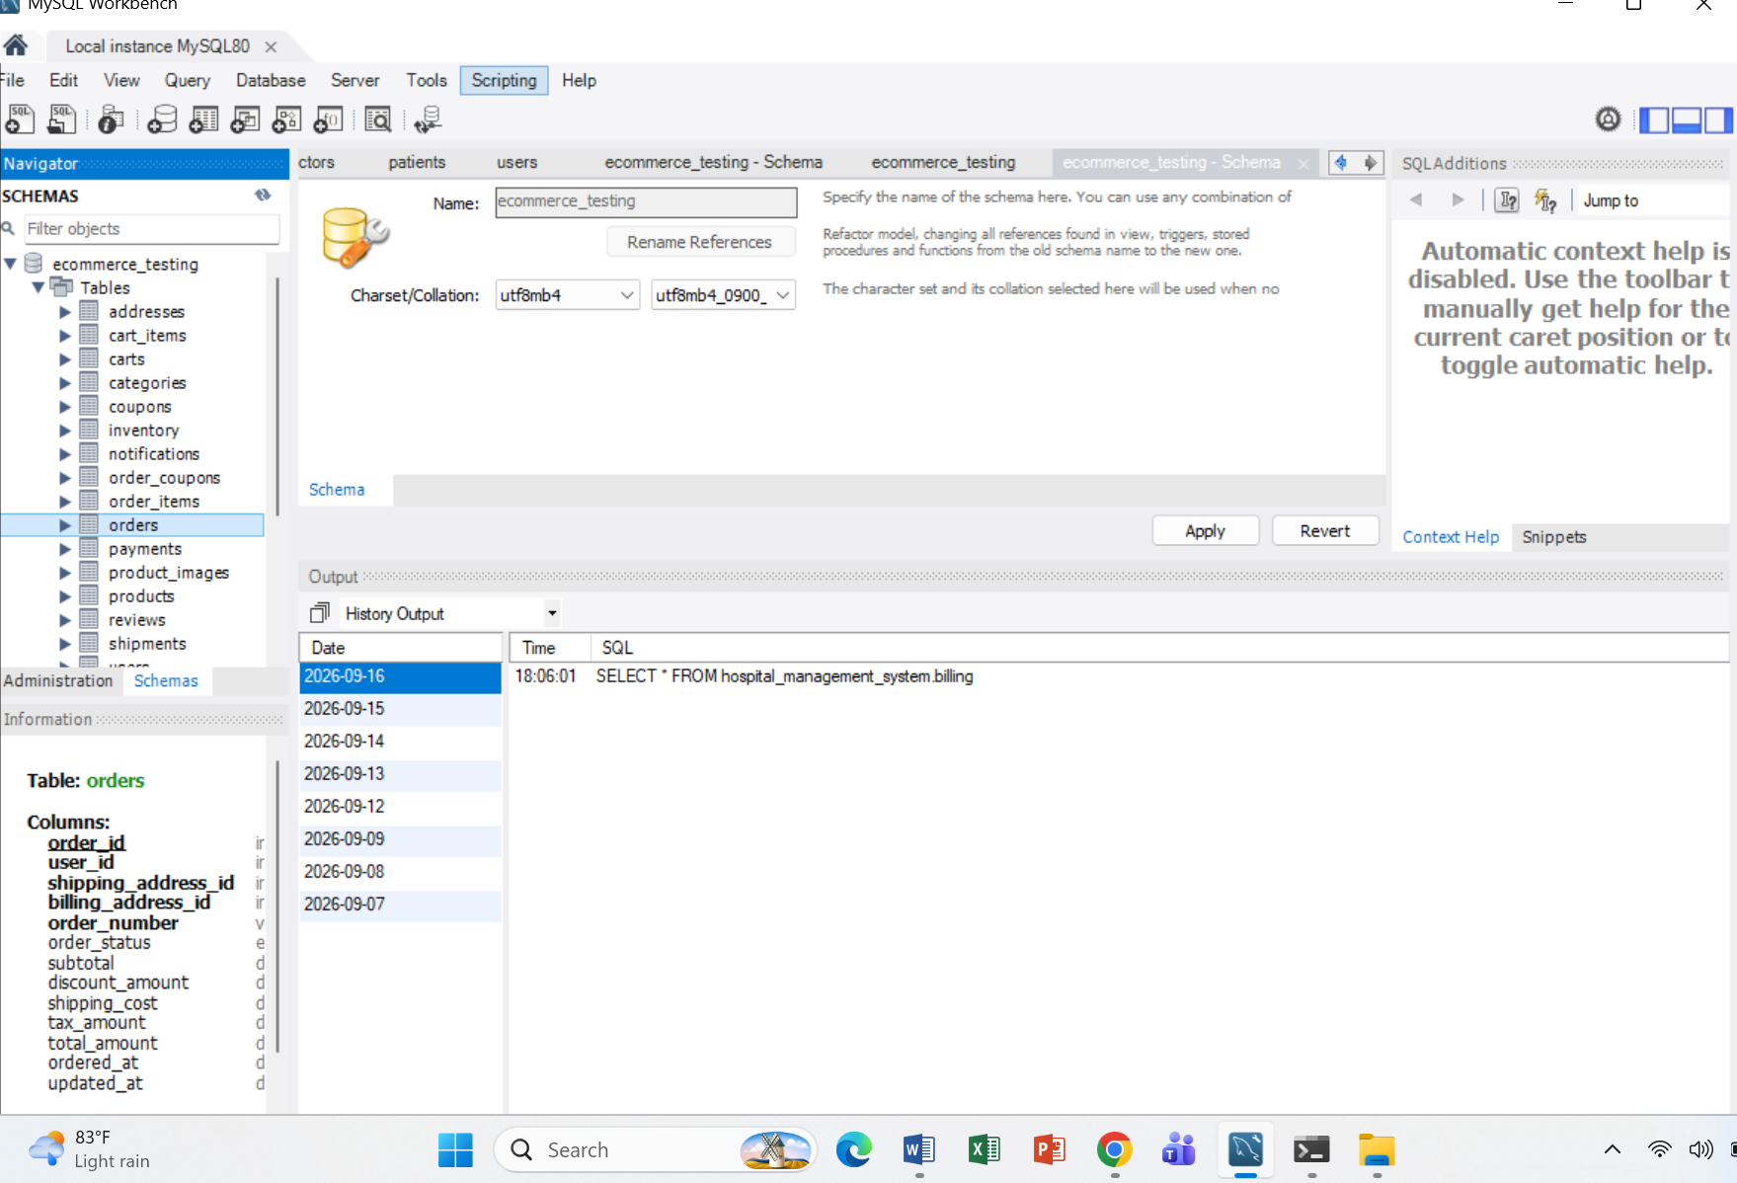
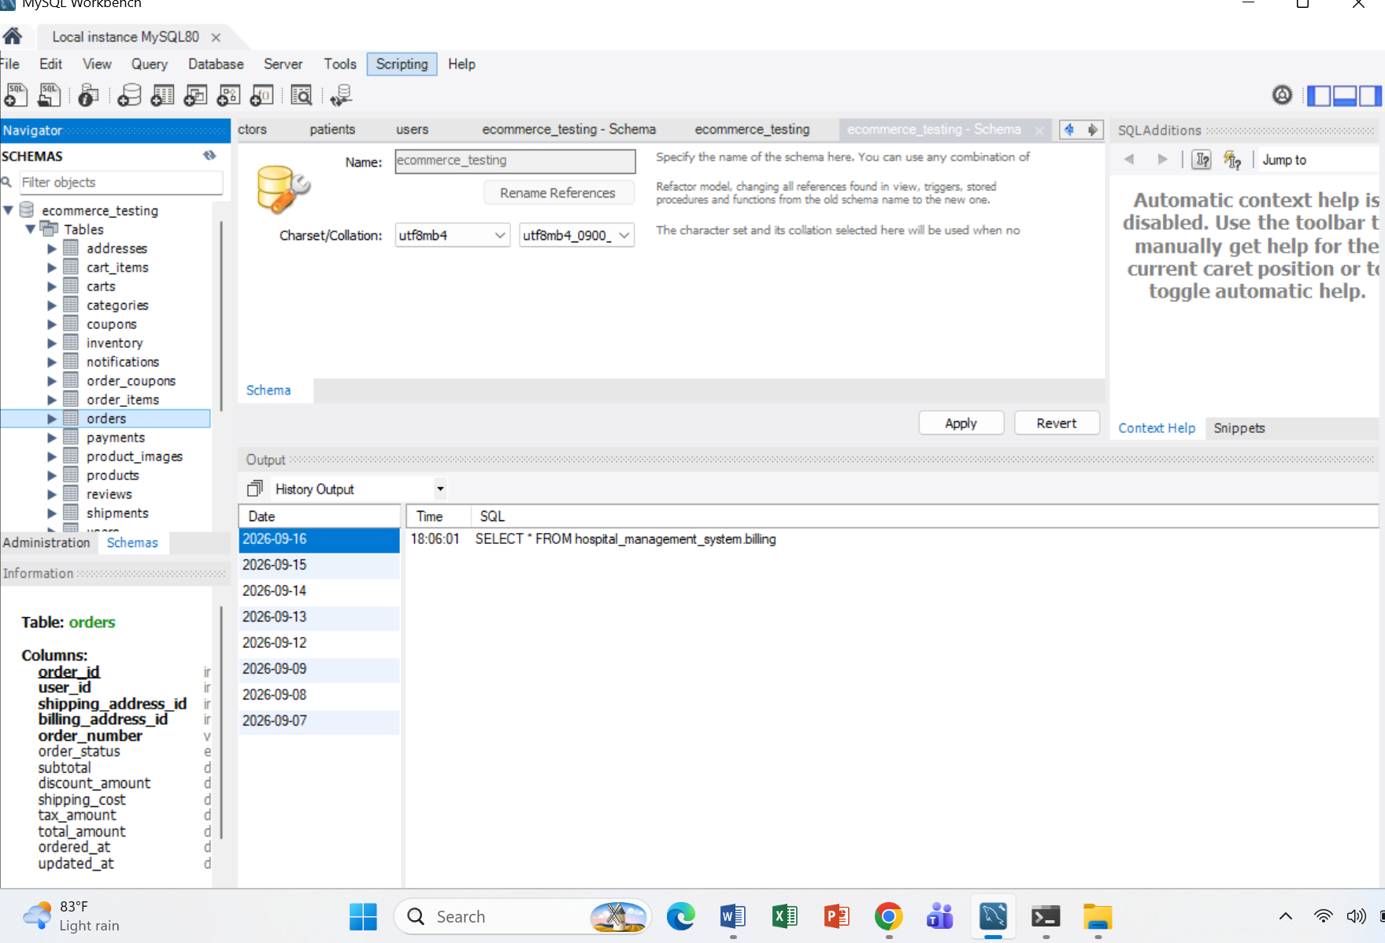

Step 03:
Data Insertion:
-- USERS
INSERT INTO users
(first_name, last_name, email, password_hash, phone, user_type, status)
VALUES
('Tasmin', 'Tahsin', 'tasmin@example.com', 'HASH001', '01710000001', 'Customer', 'Active'),
('Rahim', 'Ahmed', 'rahim@example.com', 'HASH002', '01710000002', 'Customer', 'Active'),
('Nusrat', 'Jahan', 'nusrat@example.com', 'HASH003', '01710000003', 'Customer', 'Active'),
('Admin', 'User', 'admin@example.com', 'HASH004', '01710000004', 'Admin', 'Active'),
('Karim', 'Hasan', 'karim@example.com', 'HASH005', '01710000005', 'Customer', 'Inactive');

-- ADDRESSES
INSERT INTO addresses
(user_id, address_type, address_line1, city, state, postal_code, country, is_default)
VALUES
(1, 'Both', 'House 11/B, Road 5', 'Dhaka', 'Dhaka', '1207', 'Bangladesh', TRUE),
(2, 'Shipping', 'House 22, Road 10', 'Chittagong', 'Chattogram', '4000', 'Bangladesh', TRUE),
(3, 'Both', 'House 33, Road 3', 'Sylhet', 'Sylhet', '3100', 'Bangladesh', TRUE),
(4, 'Both', 'Office 10', 'Dhaka', 'Dhaka', '1212', 'Bangladesh', TRUE),
(5, 'Shipping', 'House 55', 'Rajshahi', 'Rajshahi', '6000', 'Bangladesh', TRUE);

-- CATEGORIES
INSERT INTO categories (category_name, description)
VALUES
('Electronics', 'Electronic devices and accessories'),
('Clothing', 'Men and women clothing'),
('Books', 'Books and educational materials'),
('Home & Kitchen', 'Home and kitchen products'),
('Sports', 'Sports and fitness products');

-- PRODUCTS
INSERT INTO products
(category_id, product_name, sku, description, price, discount_percent, status)
VALUES
(1, 'Wireless Mouse', 'ELEC-001', '2.4GHz wireless mouse', 850.00, 5.00, 'Active'),
(1, 'Mechanical Keyboard', 'ELEC-002', 'RGB mechanical keyboard', 3500.00, 10.00, 'Active'),
(1, 'USB-C Cable', 'ELEC-003', 'Fast charging USB-C cable', 450.00, 0.00, 'Active'),
(2, 'Cotton T-Shirt', 'CLOT-001', 'Premium cotton t-shirt', 750.00, 5.00, 'Active'),
(2, 'Denim Jeans', 'CLOT-002', 'Regular fit denim jeans', 2200.00, 15.00, 'Active'),
(3, 'SQL for Beginners', 'BOOK-001', 'Database learning book', 650.00, 0.00, 'Active'),
(3, 'Software Testing Guide', 'BOOK-002', 'Manual and automation testing', 900.00, 10.00, 'Active'),
(4, 'Electric Kettle', 'HOME-001', '1.5 litre electric kettle', 1800.00, 8.00, 'Active'),
(5, 'Yoga Mat', 'SPRT-001', 'Non-slip exercise yoga mat', 1200.00, 5.00, 'Active'),
(5, 'Football', 'SPRT-002', 'Professional size football', 1100.00, 0.00, 'Out of Stock');

-- PRODUCT IMAGES
INSERT INTO product_images (product_id, image_url, is_primary)
VALUES
(1, 'https://example.com/images/mouse.jpg', TRUE),
(2, 'https://example.com/images/keyboard.jpg', TRUE),
(3, 'https://example.com/images/cable.jpg', TRUE),
(4, 'https://example.com/images/tshirt.jpg', TRUE),
(5, 'https://example.com/images/jeans.jpg', TRUE),
(6, 'https://example.com/images/sql-book.jpg', TRUE),
(7, 'https://example.com/images/testing-book.jpg', TRUE),
(8, 'https://example.com/images/kettle.jpg', TRUE),
(9, 'https://example.com/images/yoga-mat.jpg', TRUE),
(10, 'https://example.com/images/football.jpg', TRUE);

-- INVENTORY
INSERT INTO inventory (product_id, quantity, reorder_level)
VALUES
(1, 100, 10),
(2, 50, 10),
(3, 200, 20),
(4, 80, 10),
(5, 40, 5),
(6, 60, 10),
(7, 30, 5),
(8, 25, 5),
(9, 70, 10),
(10, 0, 5);

-- CARTS
INSERT INTO carts (user_id, status)
VALUES
(1, 'Active'),
(2, 'Active'),
(3, 'Abandoned');

-- CART ITEMS
INSERT INTO cart_items (cart_id, product_id, quantity, unit_price)
VALUES
(1, 1, 2, 850.00),
(1, 3, 1, 450.00),
(2, 4, 2, 750.00),
(3, 6, 1, 650.00);

-- ORDERS
INSERT INTO orders
(user_id, shipping_address_id, billing_address_id, order_number,
order_status, subtotal, discount_amount, shipping_cost, tax_amount, total_amount)
VALUES
(1, 1, 1, 'ORD-10001', 'Delivered', 1700.00, 85.00, 60.00, 80.00, 1755.00),
(2, 2, 2, 'ORD-10002', 'Processing', 2950.00, 295.00, 80.00, 130.00, 2865.00),
(3, 3, 3, 'ORD-10003', 'Cancelled', 650.00, 0.00, 60.00, 32.50, 742.50);

-- ORDER ITEMS
INSERT INTO order_items
(order_id, product_id, quantity, unit_price, discount_amount, line_total)
VALUES
(1, 1, 2, 850.00, 85.00, 1615.00),
(2, 5, 1, 2200.00, 220.00, 1980.00),
(2, 4, 1, 750.00, 75.00, 675.00),
(3, 6, 1, 650.00, 0.00, 650.00);

-- PAYMENTS
INSERT INTO payments
(order_id, payment_method, transaction_id, amount, payment_status, paid_at)
VALUES
(1, 'Card', 'TXN-10001', 1755.00, 'Paid', CURRENT_TIMESTAMP),
(2, 'Mobile Banking', 'TXN-10002', 2865.00, 'Paid', CURRENT_TIMESTAMP),
(3, 'Cash on Delivery', NULL, 742.50, 'Failed', NULL);

-- SHIPMENTS
INSERT INTO shipments
(order_id, courier_name, tracking_number, shipment_status, shipped_at, delivered_at)
VALUES
(1, 'Pathao Courier', 'TRK-10001', 'Delivered',
DATE_SUB(CURRENT_TIMESTAMP, INTERVAL 5 DAY),
DATE_SUB(CURRENT_TIMESTAMP, INTERVAL 2 DAY)),
(2, 'Sundarban Courier', 'TRK-10002', 'In Transit',
DATE_SUB(CURRENT_TIMESTAMP, INTERVAL 1 DAY), NULL),
(3, NULL, NULL, 'Pending', NULL, NULL);

-- COUPONS
INSERT INTO coupons
(coupon_code, description, discount_type, discount_value,
minimum_order_amount, usage_limit, used_count,
start_date, end_date, status)
VALUES
('WELCOME10', '10 percent welcome discount', 'Percentage', 10.00,
1000.00, 100, 5,
DATE_SUB(CURRENT_TIMESTAMP, INTERVAL 30 DAY),
DATE_ADD(CURRENT_TIMESTAMP, INTERVAL 60 DAY), 'Active'),

('SAVE500', '500 taka discount', 'Fixed', 500.00,
3000.00, 50, 10,
DATE_SUB(CURRENT_TIMESTAMP, INTERVAL 10 DAY),
DATE_ADD(CURRENT_TIMESTAMP, INTERVAL 20 DAY), 'Active'),

('OLD20', 'Expired test coupon', 'Percentage', 20.00,
500.00, 20, 20,
DATE_SUB(CURRENT_TIMESTAMP, INTERVAL 60 DAY),
DATE_SUB(CURRENT_TIMESTAMP, INTERVAL 30 DAY), 'Expired');

-- ORDER COUPONS
INSERT INTO order_coupons (order_id, coupon_id, discount_amount)
VALUES
(1, 1, 85.00),
(2, 2, 295.00);

-- REVIEWS
INSERT INTO reviews
(user_id, product_id, order_id, rating, review_title, review_text, status)
VALUES
(1, 1, 1, 5, 'Excellent Mouse', 'Very smooth and comfortable.', 'Approved'),
(2, 5, 2, 4, 'Good Jeans', 'Good quality and fitting.', 'Approved'),
(3, 6, 3, 3, 'Useful Book', 'Good for beginners.', 'Pending');

-- WISHLISTS
INSERT INTO wishlists (user_id, wishlist_name)
VALUES
(1, 'My Wishlist'),
(2, 'Favorite Products'),
(3, 'Books to Buy');

-- WISHLIST ITEMS
INSERT INTO wishlist_items (wishlist_id, product_id)
VALUES
(1, 2),
(1, 8),
(2, 5),
(2, 9),
(3, 7);

-- NOTIFICATIONS
INSERT INTO notifications
(user_id, title, message, notification_type, reference_id, is_read, read_at)
VALUES
(1, 'Order Delivered', 'Your order ORD-10001 has been delivered.',
'Order', 1, TRUE, CURRENT_TIMESTAMP),
(2, 'Order Processing', 'Your order ORD-10002 is being processed.',
'Order', 2, FALSE, NULL),
(3, 'Welcome', 'Welcome to our e-commerce website.',
'System', NULL, FALSE, NULL);
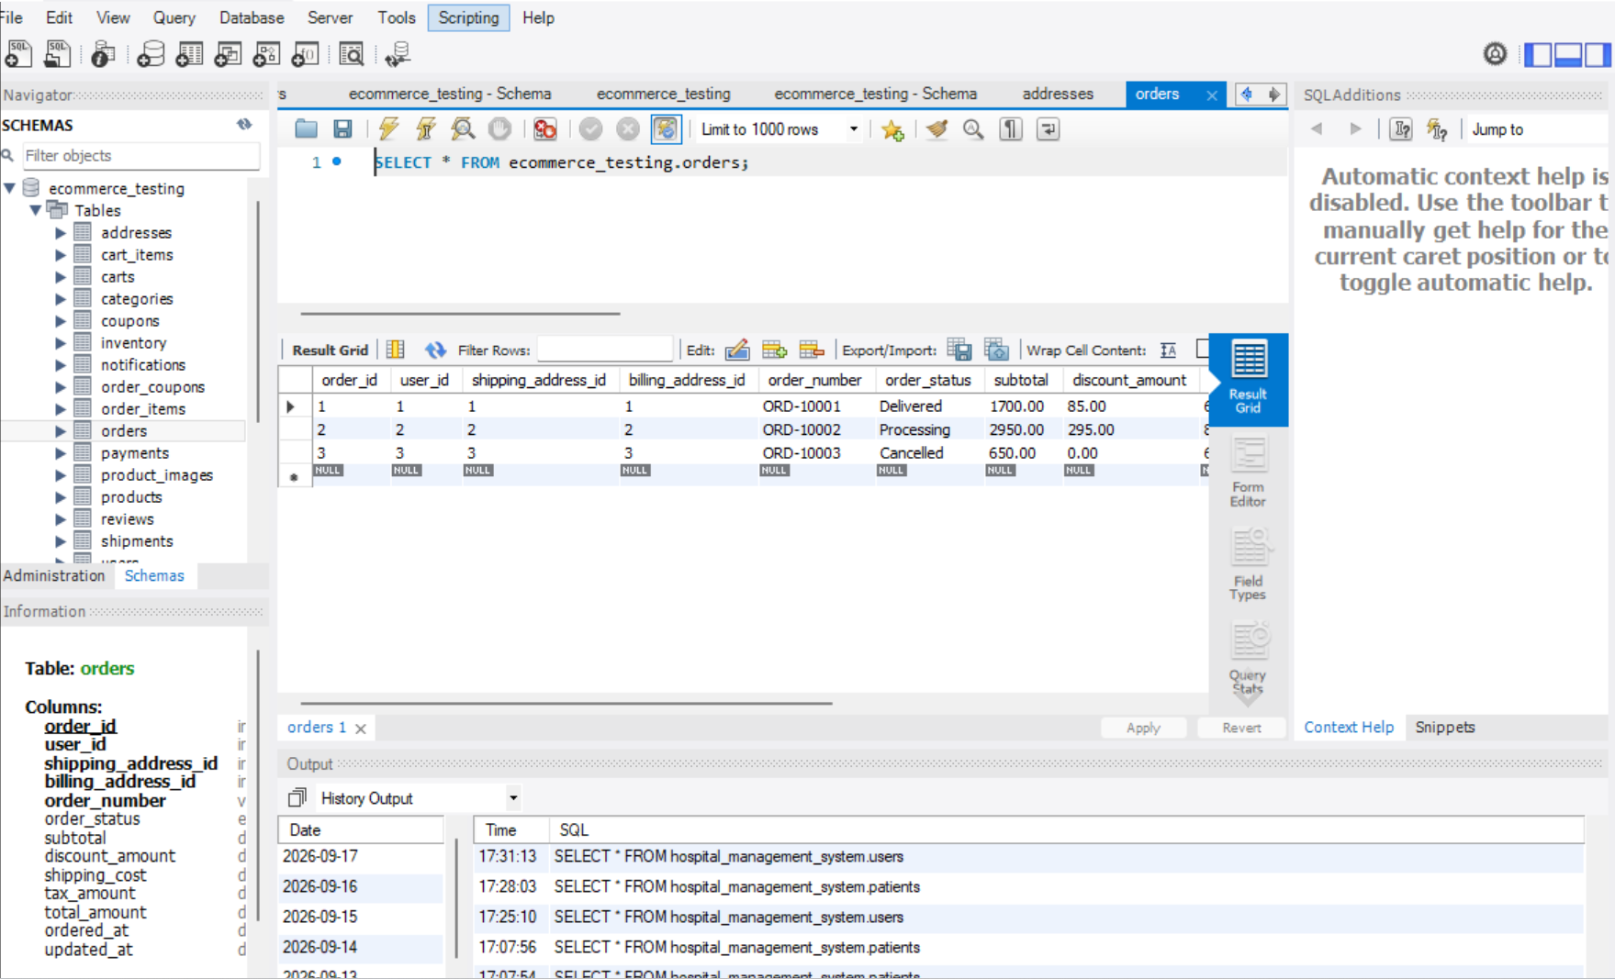
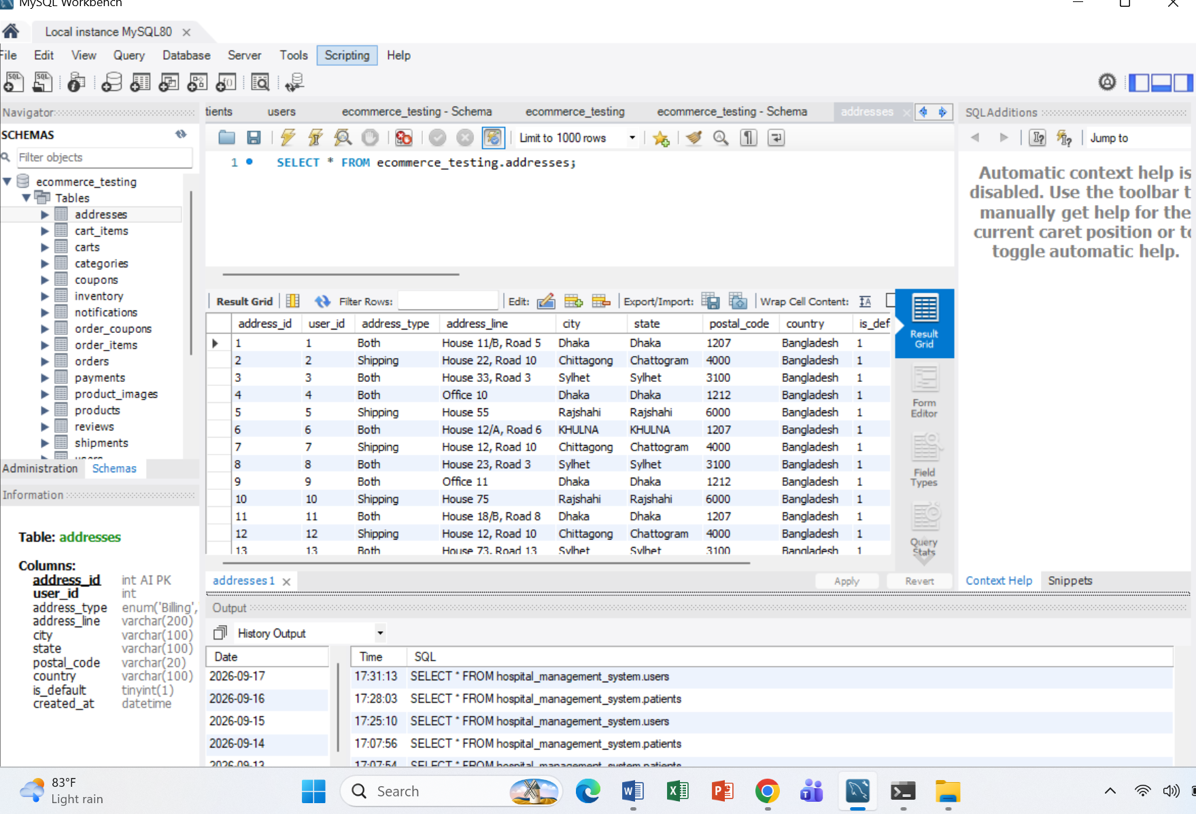
Step 04:
ER Diagram:
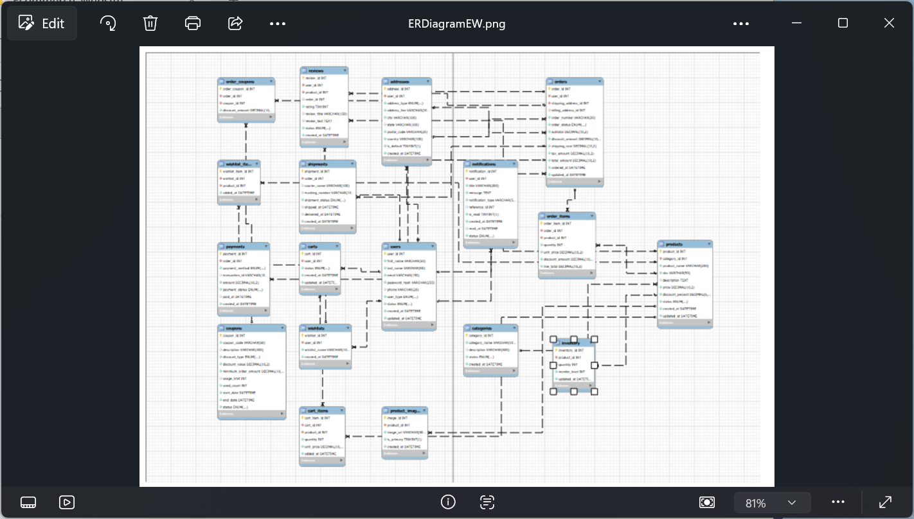
Step 05:
Database Verification:
CRUD Testing: C = Create, R = Read, U = Update, D = Delete
Create / INSERT:
Test whether a new record can be added correctly.
INSERT INTO products
(category_id, product_name, sku, description, price)
VALUES
(1, 'Bluetooth Speaker', 'ELEC-011',
'Portable Bluetooth speaker', 2500.00);
Test: Was the product successfully added?
SELECT * FROM products
WHERE sku = 'ELEC-011';
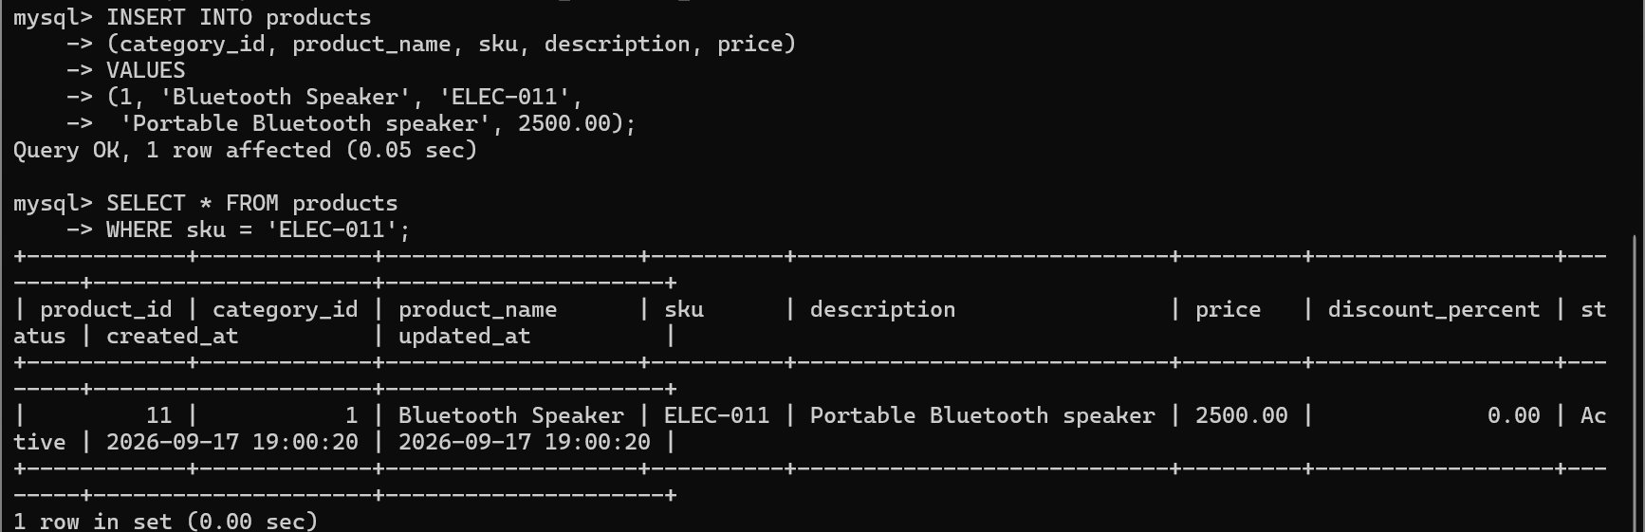
Read:
You test whether stored data can be retrieved correctly.
SELECT product_name, price, status
FROM products
WHERE category_id = 1;
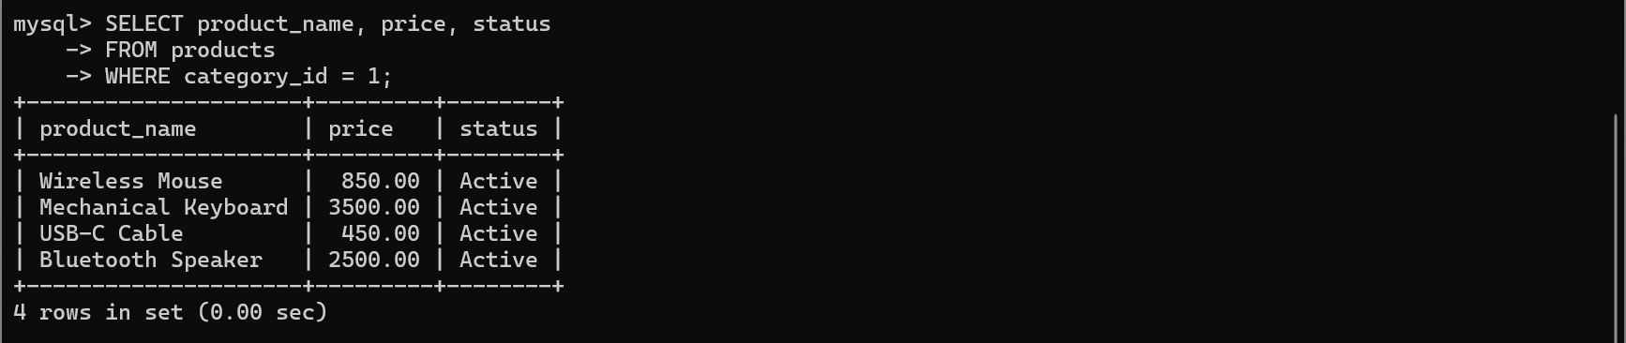

UPDATE — Modify existing data
You test whether existing information can be changed.
UPDATE products
SET price = 2700.00
WHERE sku = 'ELEC-011';
Then verify:
SELECT product_name, price
FROM products
WHERE sku = 'ELEC-011';
Expected:
Bluetooth Speaker | 2700.00
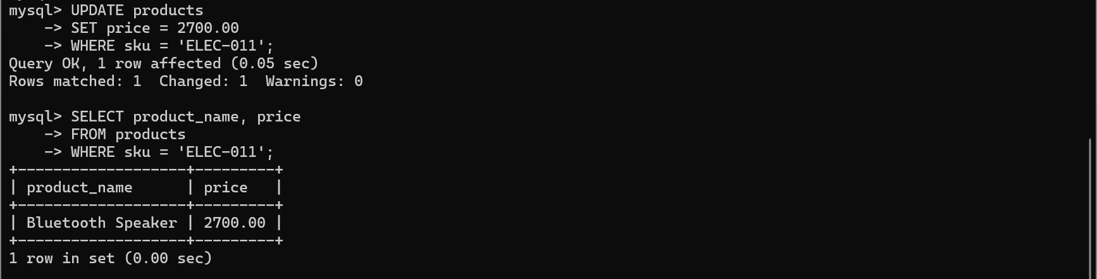

DELETE — Remove data
You test whether a record can be deleted correctly.
DELETE FROM products
WHERE sku = 'ELEC-011';
Verify:
SELECT *
FROM products
WHERE sku = 'ELEC-011';
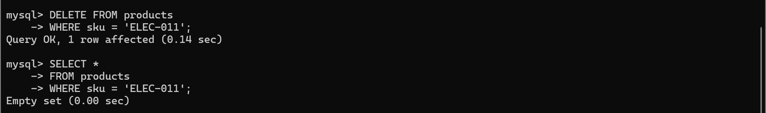

Primary Key (PK) testing:
A Primary Key uniquely identifies each record in a table.
For example, your products table has:
product_id INT AUTO_INCREMENT PRIMARY KEY
So every product must have a unique product_id.

Test 1 — Check uniqueness
SELECT product_id, COUNT(*)
FROM products
GROUP BY product_id
HAVING COUNT(*) > 1;
Expected: No rows.
This verifies that there are no duplicate primary keys.

Test 2 — Check NULL
A primary key cannot be NULL.
SELECT *
FROM products
WHERE product_id IS NULL;
Expected: No rows.
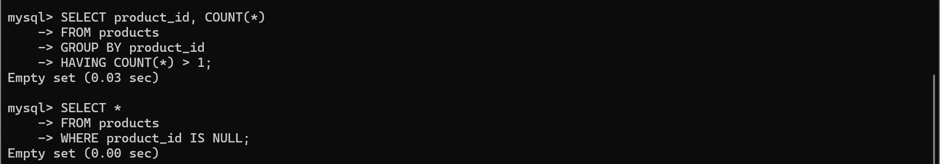

Foreign Key (FK) testing:
A Foreign Key connects one table to another.
INSERT INTO products
(category_id, product_name, sku, price)
VALUES
(1, 'Test Keyboard', 'TEST-001', 1500.00);
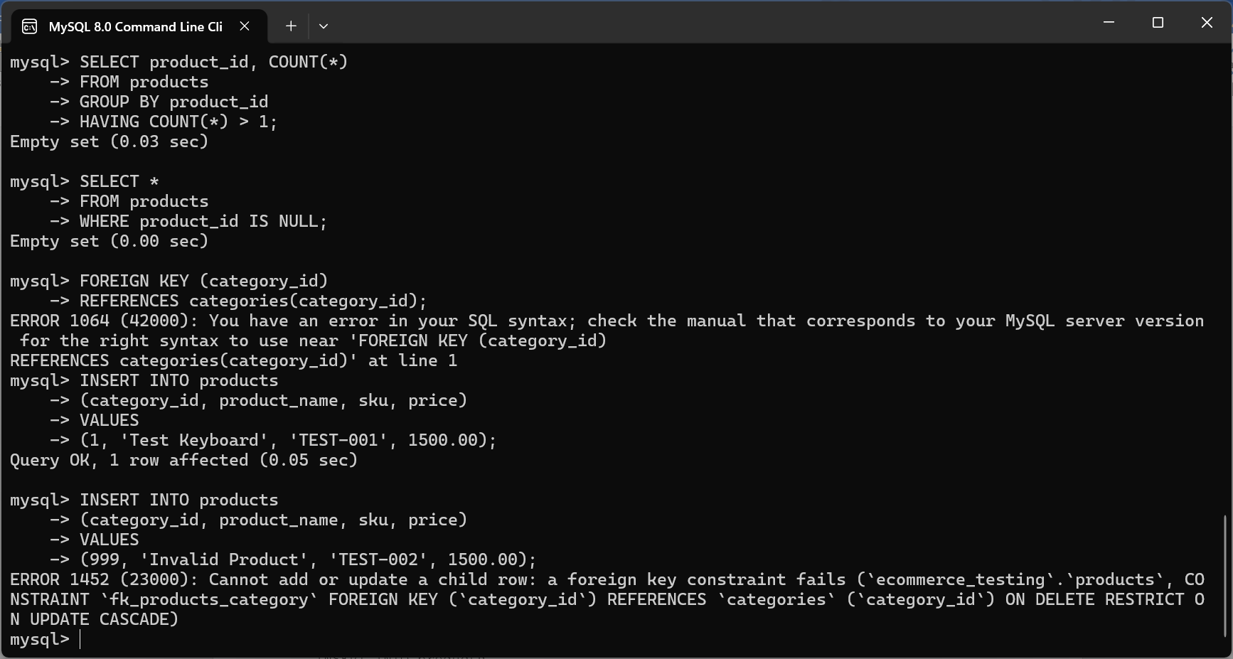

Invalid Foreign Key:
Try using a category that doesn't exist:
INSERT INTO products
(category_id, product_name, sku, price)
VALUES
(999, 'Invalid Product', 'TEST-002', 1500.00);

Duplicate data:

Search for duplicates:
SELECT email, COUNT(*) AS duplicate_count
FROM users
GROUP BY email
HAVING COUNT(*) > 1;
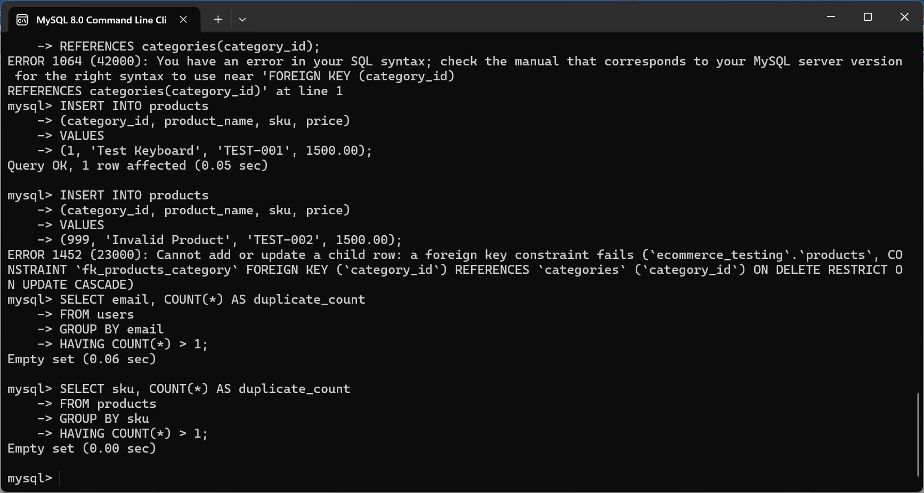
Expected: Empty result
For product SKU:
SELECT sku, COUNT(*) AS duplicate_count
FROM products
GROUP BY sku
HAVING COUNT(*) > 1;
Expected: Empty result
INNER JOIN Testing:
Suppose you want to see which customers placed orders.
SELECT
u.user_id,
u.first_name,
u.email,
o.order_number,
o.order_status
FROM users u
INNER JOIN orders o
ON u.user_id = o.user_id;
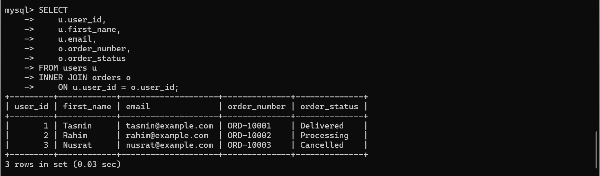
JOIN Orders + Products:
This is one of the most useful tests for your e-commerce database.
SELECT
o.order_number,
p.product_name,
oi.quantity,
oi.unit_price,
oi.line_total
FROM orders o
JOIN order_items oi
ON o.order_id = oi.order_id
JOIN products p
ON oi.product_id = p.product_id;
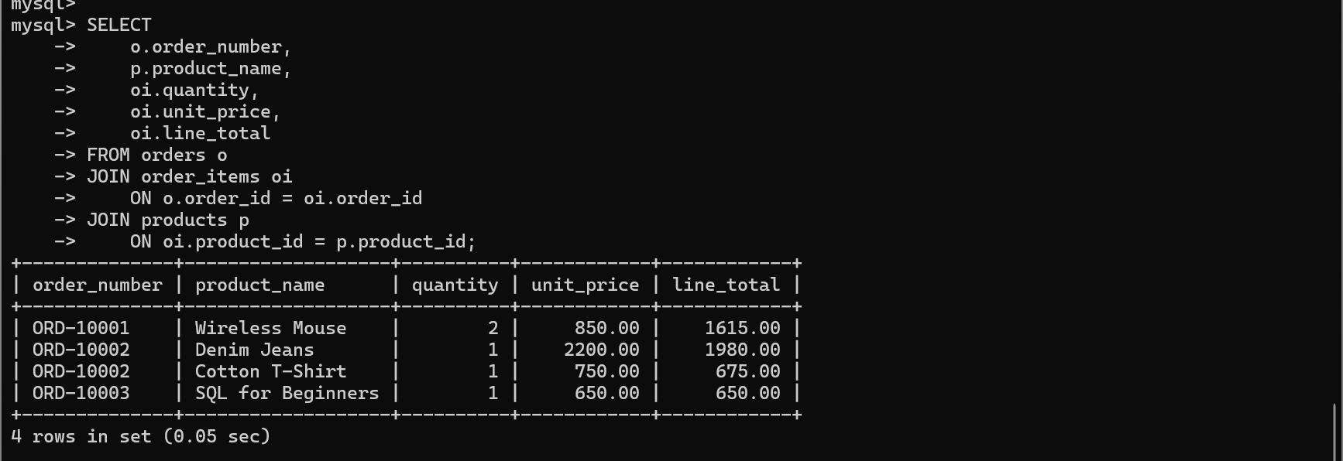
LEFT JOIN Testing:
LEFT JOIN is useful for finding records that don't have a matching record.
For example:
SELECT
p.product_id,
p.product_name,
i.quantity
FROM products p
LEFT JOIN inventory i
ON p.product_id = i.product_id;
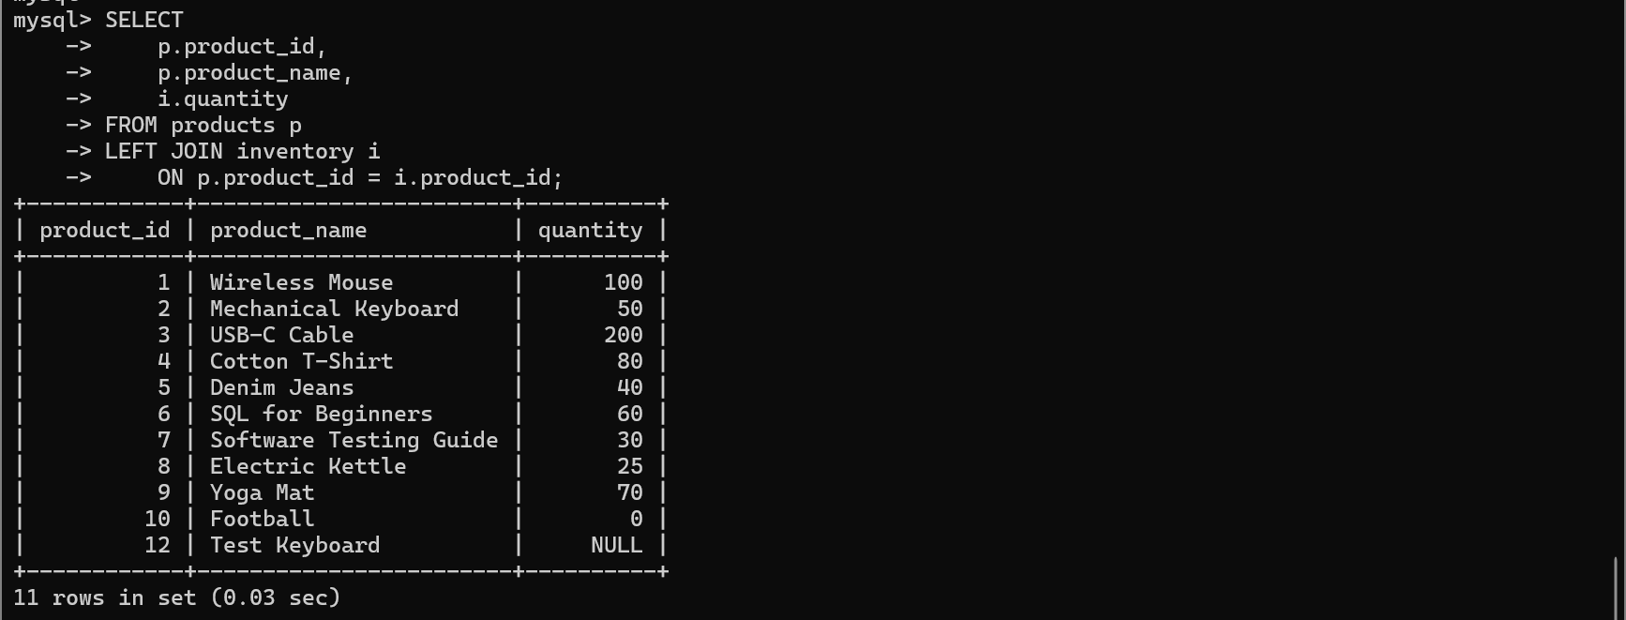
JOIN + Aggregation Testing:
You can test total sales per product:
SELECT
p.product_name,
SUM(oi.quantity) AS total_quantity_sold,
SUM(oi.line_total) AS total_sales
FROM products p
JOIN order_items oi
ON p.product_id = oi.product_id
JOIN orders o
ON oi.order_id = o.order_id
WHERE o.order_status <> 'Cancelled'
GROUP BY p.product_id, p.product_name;
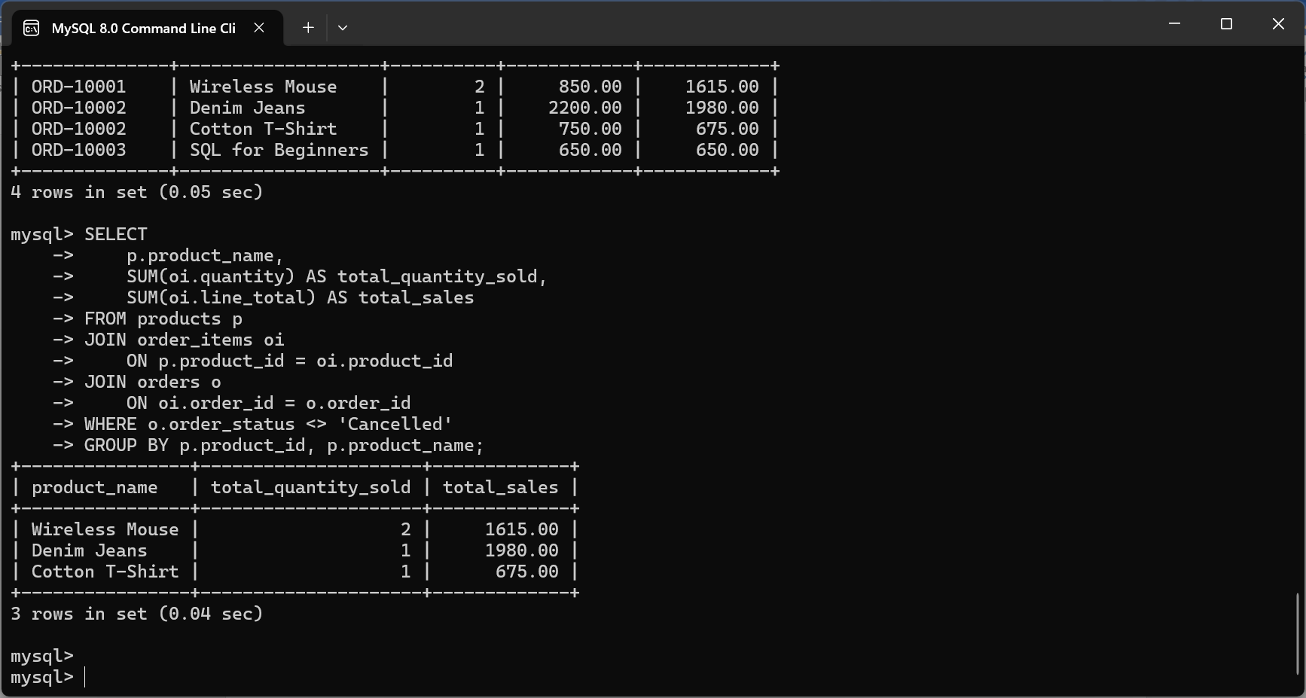
Aggregate Functions Testing:

1. COUNT() — Count records
Count all products:
SELECT COUNT(*) AS total_products
FROM products;
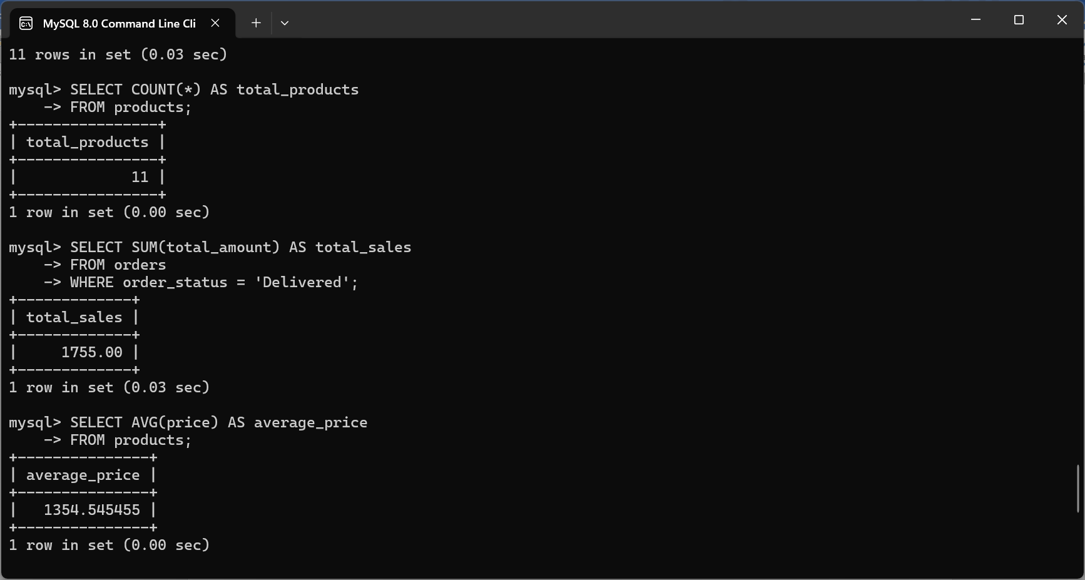

2. SUM() — Calculate total
Calculate the total value of all inventory:
SELECT SUM(quantity) AS total_stock
FROM inventory;
You can also calculate total sales:
SELECT SUM(total_amount) AS total_sales
FROM orders
WHERE order_status = 'Delivered';

3. AVG() — Calculate average
Find the average product price:
SELECT AVG(price) AS average_price
FROM products;

4. MIN() — Find the smallest value
Find the cheapest product:
SELECT MIN(price) AS lowest_price
FROM products;
To see the actual product:
SELECT product_name, price
FROM products
WHERE price = (
SELECT MIN(price)
FROM products
);
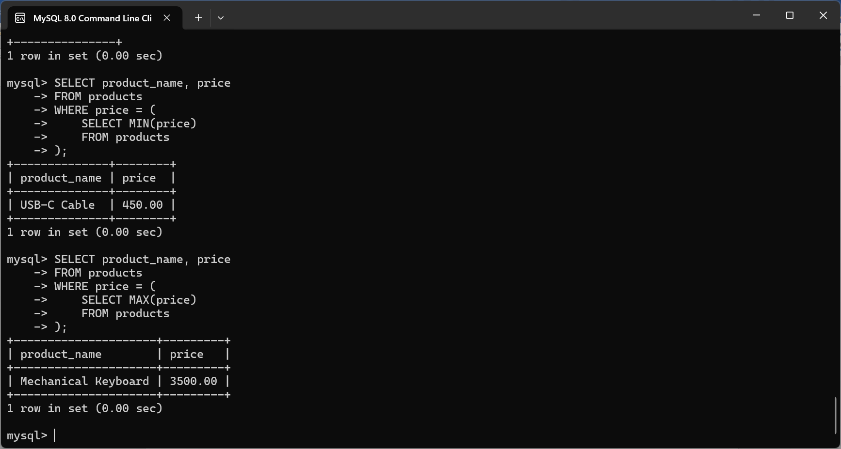

5. MAX() — Find the largest value
Find the highest product price:
SELECT MAX(price) AS highest_price
FROM products;
To see the product:
SELECT product_name, price
FROM products
WHERE price = (
SELECT MAX(price)
FROM products
);
Order Total Validation:

1. Check an existing order:
For example, order ORD-10001:
SELECT
order_number,
subtotal,
discount_amount,
shipping_cost,
tax_amount,
total_amount
FROM orders
WHERE order_number = 'ORD-10001';
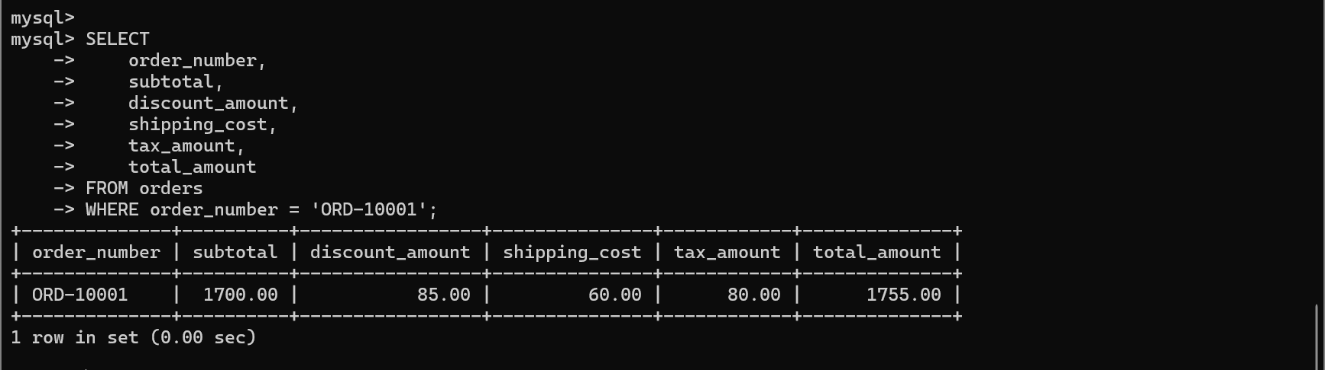

2. Calculate the expected total:
You can calculate the expected value directly:
SELECT
order_number,
subtotal,
discount_amount,
shipping_cost,
tax_amount,
total_amount,

(subtotal
- discount_amount
+ shipping_cost
+ tax_amount) AS expected_total

FROM orders;
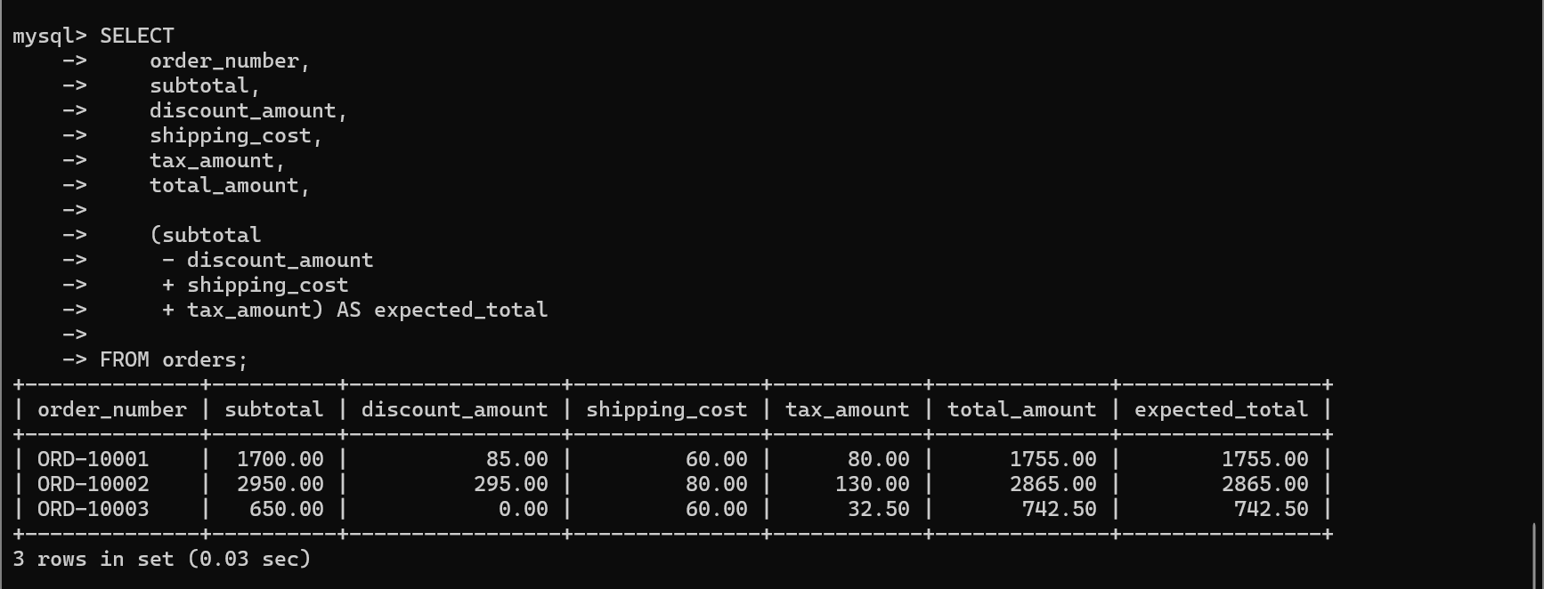

3. Automatically find incorrect orders:
This is a very useful database-testing query:
SELECT
order_id,
order_number,
total_amount,
(
subtotal
- discount_amount
+ shipping_cost
+ tax_amount
) AS expected_total
FROM orders
WHERE total_amount <> (
subtotal
- discount_amount
+ shipping_cost
+ tax_amount
);

Expected result: Empty result

4. Validate Order Items Against Subtotal
SQL:
SELECT
o.order_number,
o.subtotal,
SUM(
oi.quantity * oi.unit_price
- oi.discount_amount
) AS expected_subtotal
FROM orders o
JOIN order_items oi
ON o.order_id = oi.order_id
GROUP BY
o.order_id,
o.order_number,
o.subtotal;
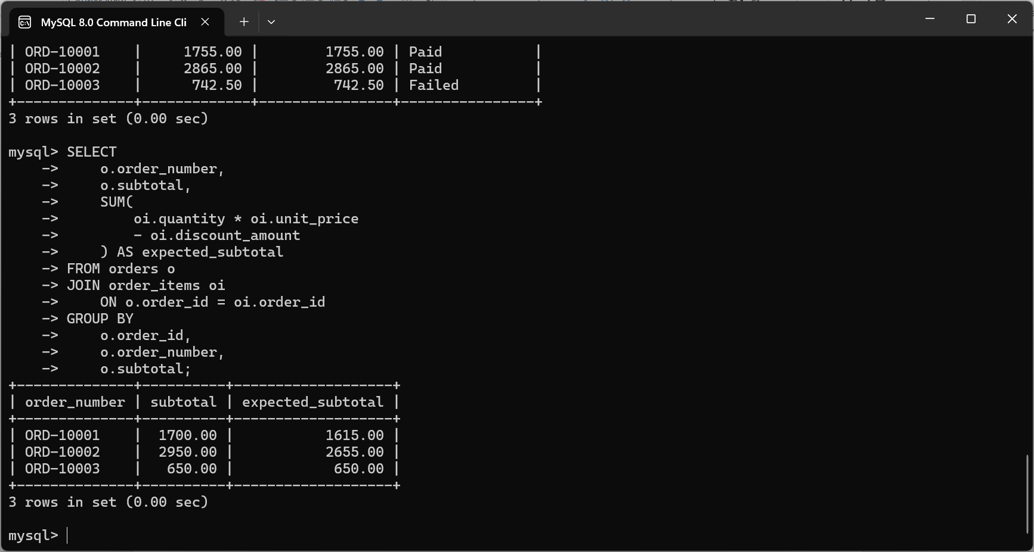
Payment Validation:

1. Check payment amount against order total
SELECT
o.order_number,
o.total_amount AS order_total,
p.amount AS payment_amount,
p.payment_status
FROM orders o
JOIN payments p
ON o.order_id = p.order_id;
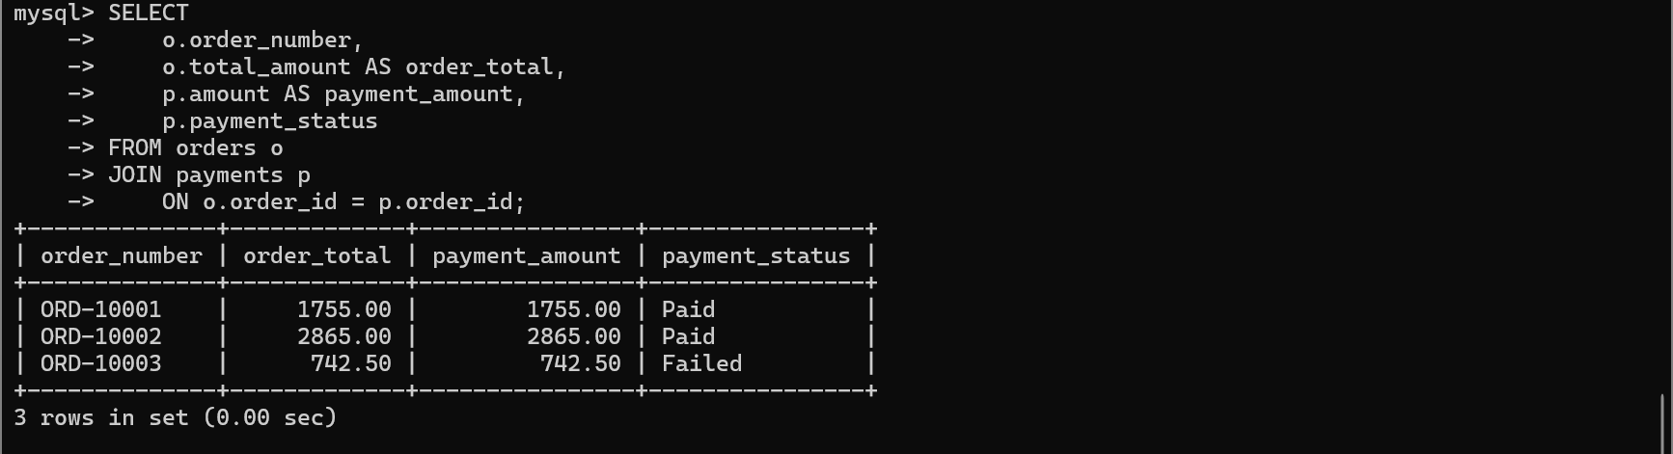

2. Check that payment references a valid order
Because payments.order_id is a Foreign Key:
FOREIGN KEY (order_id)
REFERENCES orders(order_id)
Try:
INSERT INTO payments
(order_id, payment_method, amount, payment_status)
VALUES
(9999, 'Card', 1000.00, 'Paid');
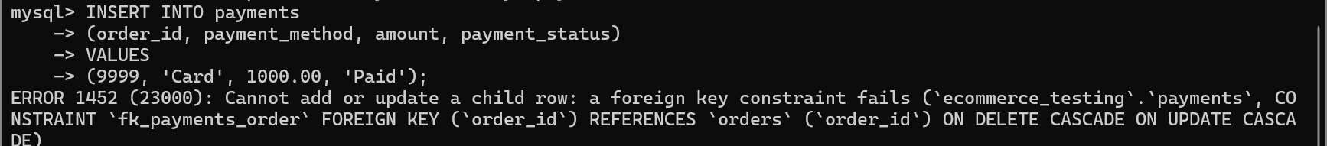
This error is expected and correct for database testing project. You are testing Foreign Key validation.

Expected :Insert should fail because order 9999 doesn't exist.

3. Transaction ID duplicate testing
INSERT INTO payments
(order_id, payment_method, transaction_id, amount, payment_status)
VALUES
(2, 'Card', 'TXN-10001', 2865.00, 'Paid');
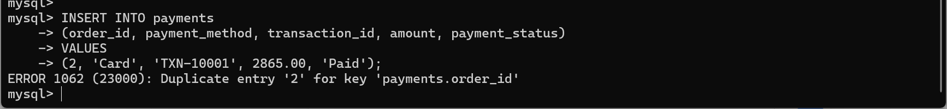
This error is because your payments table allows only one payment record per order.

Expected: Insert should fail because the transaction ID already exists.

4. Payment status validation
You can check the different payment statuses:
SELECT
payment_status,
COUNT(*) AS total_payments
FROM payments
GROUP BY payment_status;
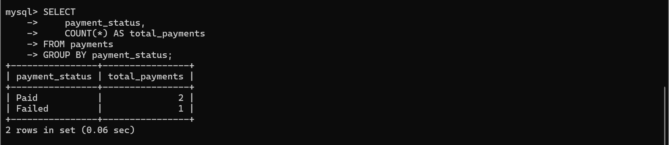
Data Consistency Testing:

1. Order Total Consistency
SELECT
order_number,
total_amount,
(
subtotal
- discount_amount
+ shipping_cost
+ tax_amount
) AS calculated_total
FROM orders
WHERE total_amount <> (
subtotal
- discount_amount
+ shipping_cost
+ tax_amount
);
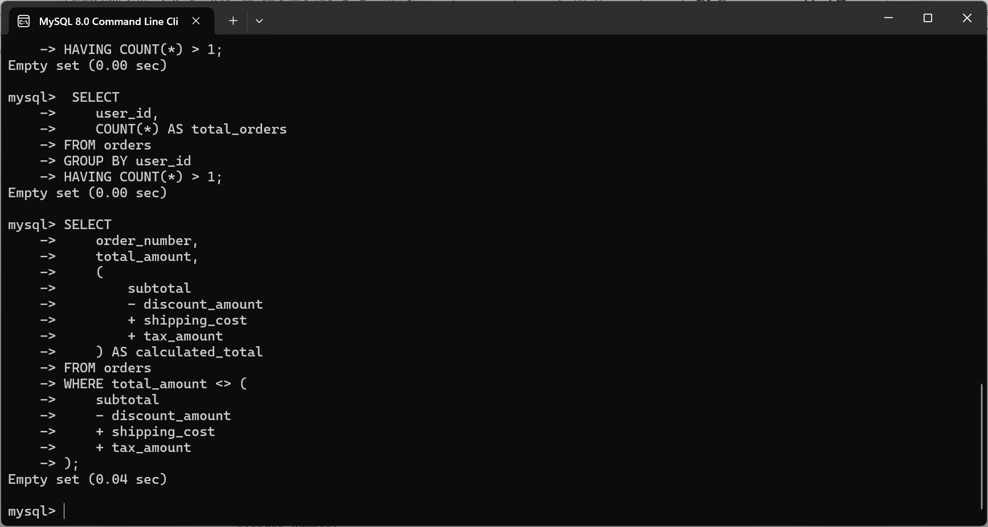

Expected: Empty result

2. Payment Consistency
The payment amount should normally match the order total for a fully paid order.
SELECT
o.order_number,
o.total_amount,
p.amount AS payment_amount,
p.payment_status
FROM orders o
JOIN payments p
ON o.order_id = p.order_id
WHERE p.payment_status = 'Paid'
AND p.amount <> o.total_amount;

Expected : Empty result

3. Customer and Order Consistency
Every order should belong to an existing customer.
SELECT
o.order_id,
o.order_number,
o.user_id
FROM orders o
LEFT JOIN users u
ON o.user_id = u.user_id
WHERE u.user_id IS NULL;

Expected: Empty result

Aggregate FuctionTesting:

1: Find customers with multiple orders
SELECT
user_id,
COUNT(*) AS total_orders
FROM orders
GROUP BY user_id
HAVING COUNT(*) > 1;
This is useful for verifying whether customer order counts are calculated correctly

2: Find products ordered more than once
SELECT
product_id,
COUNT(*) AS order_count
FROM order_items
GROUP BY product_id
HAVING COUNT(*) > 1;
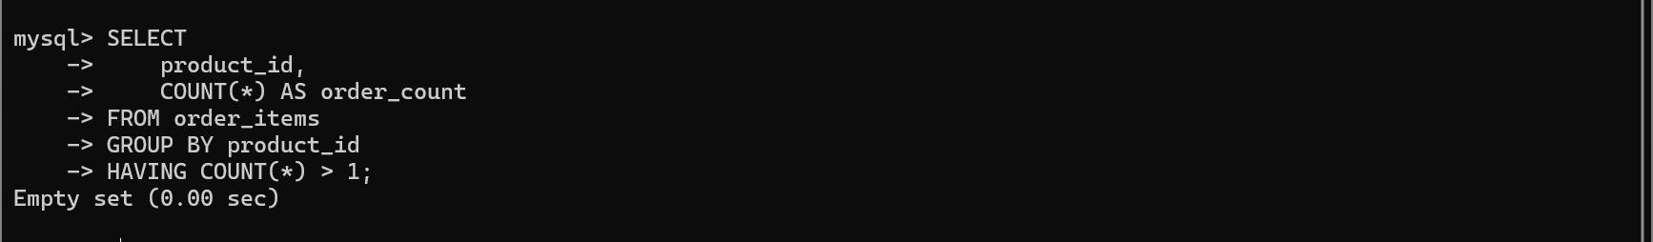
This checks which products appear in multiple order-item records.

3: Calculate total sales by customer
SELECT
o.user_id,
SUM(o.total_amount) AS total_spent
FROM orders o
WHERE o.order_status <> 'Cancelled'
GROUP BY o.user_id;
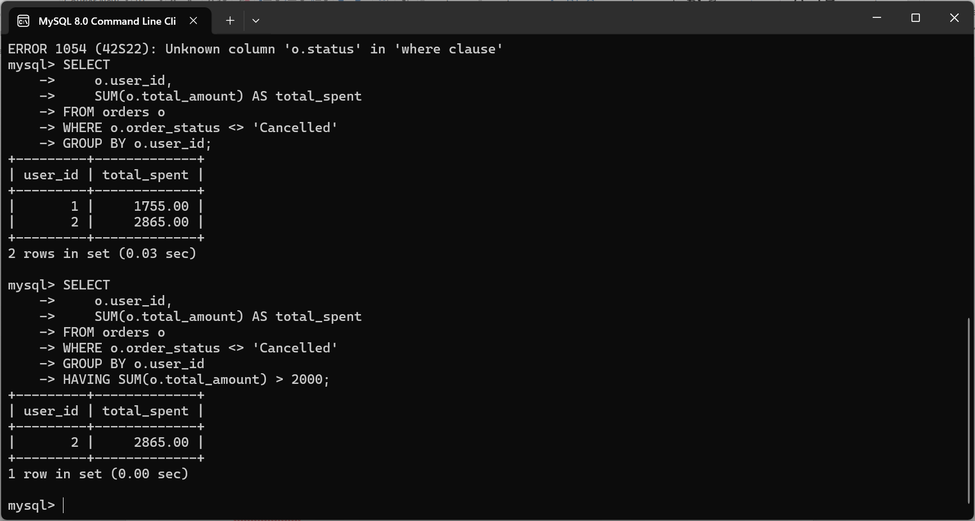
Then find customers who spent more than 2,000:
SELECT
o.user_id,
SUM(o.total_amount) AS total_spent
FROM orders o
WHERE o.order_status <> 'Cancelled'
GROUP BY o.user_id
HAVING SUM(o.total_amount) > 2000;;

Real-World E-commerce Business-Rule Testing:

1. Product cannot be sold when out of stock
Business rule: If inventory quantity is 0, the product should not be available for purchase.
Test:
SELECT
p.product_id,
p.product_name,
p.status AS product_status,
i.quantity,
i.status AS inventory_status
FROM products p
JOIN inventory i
ON p.product_id = i.product_id
WHERE i.quantity = 0
AND p.status = 'Active';
Expected: No rows.
If a product has:
quantity = 0
status = Active
it may indicate a business-rule violation.

2. Order total must be correct
Business rule: Total = Subtotal - Discount + Shipping + Tax
Test:
SELECT
order_number,
subtotal,
discount_amount,
shipping_cost,
tax_amount,
total_amount,
(subtotal - discount_amount + shipping_cost + tax_amount)
AS calculated_total
FROM orders
WHERE total_amount <>
(subtotal - discount_amount + shipping_cost + tax_amount);
Expected: 0 rows
This detects incorrect order totals.

3. Paid payment must match order total
Business rule: A successful payment should normally equal the amount due for the order.
SELECT
o.order_number,
o.total_amount,
p.amount AS payment_amount,
p.payment_status
FROM orders o
JOIN payments p
ON o.order_id = p.order_id
WHERE p.payment_status = 'Paid'
AND p.amount <> o.total_amount;
Expected: No rows.

4. Paid payment should have a payment date
Business rule: If payment status is Paid, paid_at should not be NULL.
SELECT
payment_id,
order_id,
payment_status,
paid_at
FROM payments
WHERE payment_status = 'Paid'
AND paid_at IS NULL;
Expected: No rows.

5. Cancelled orders should not have successful payments
Business rule: A cancelled order should not normally remain in a successful-payment state without an appropriate refund/business process.
SELECT
o.order_number,
o.status AS order_status,
p.payment_status
FROM orders o
JOIN payments p
ON o.order_id = p.order_id
WHERE o.status = 'Cancelled'
AND p.payment_status = 'Paid';
This result needs business interpretation. In a real system, a cancelled order may have been paid and subsequently refunded.
A stronger rule would be:
Cancelled + Paid → Refund process required

6. Review should only be allowed for purchased products
This is a very realistic e-commerce rule.
Business rule: A customer should only be able to review a product that they purchased.
Test:
SELECT
r.review_id,
r.user_id,
r.product_id
FROM reviews r
LEFT JOIN orders o
ON r.user_id = o.user_id
LEFT JOIN order_items oi
ON o.order_id = oi.order_id
AND r.product_id = oi.product_id
WHERE oi.order_item_id IS NULL;
Expected: No rows, if your business requires verified purchases before reviews.

7. Coupon should not be applied below minimum order amount
Suppose a coupon has:
minimum_order_amount = 2000
but is applied to an order worth only 1500.
That is a business-rule violation.
Example:
SELECT
o.order_number,
o.total_amount,
c.coupon_code,
c.minimum_order_amount
FROM orders o
JOIN order_coupons oc
ON o.order_id = oc.order_id
JOIN coupons c
ON oc.coupon_id = c.coupon_id
WHERE o.total_amount < c.minimum_order_amount;
Expected: No rows.

8. Product discount must remain within business limits
Your database already has:
CHECK (discount_percent BETWEEN 0 AND 100)
Test:
SELECT
product_id,
product_name,
discount_percent
FROM products
WHERE discount_percent < 0
OR discount_percent > 100;
Expected: No rows.

9. Inventory should not become negative
Business rule: A product cannot have negative stock.
SELECT
product_id,
quantity
FROM inventory
WHERE quantity < 0;
Expected: No rows.
Your CHECK (quantity >= 0) should also prevent this at insertion/update time.

10. Order items should belong to the correct order
Business rule: Every order item must reference an existing order and product.
SELECT
oi.order_item_id,
oi.order_id,
oi.product_id
FROM order_items oi
LEFT JOIN orders o
ON oi.order_id = o.order_id
LEFT JOIN products p
ON oi.product_id = p.product_id
WHERE o.order_id IS NULL
OR p.product_id IS NULL;
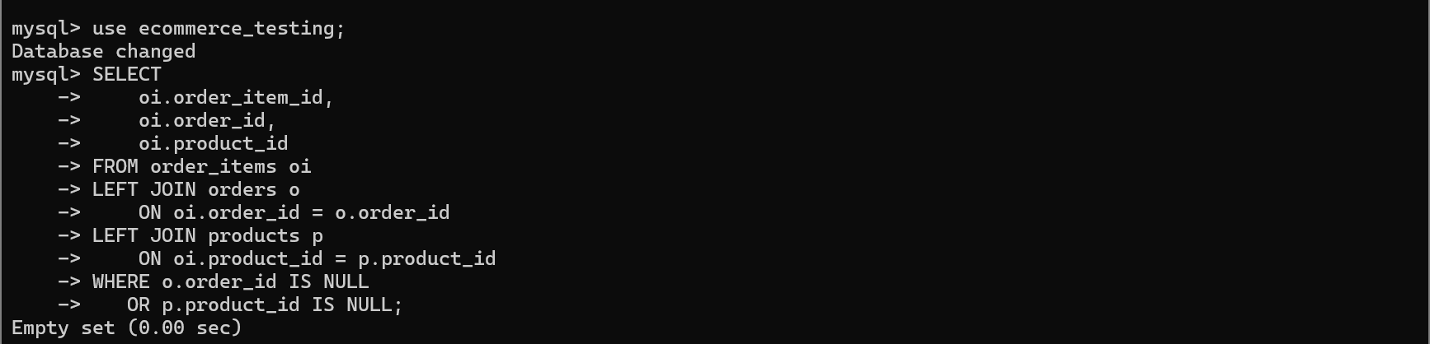
Expected: No rows.
Author:Tasmin Jannat Tahsin

